OLD STIRLING BRIDGE

BRIDGE

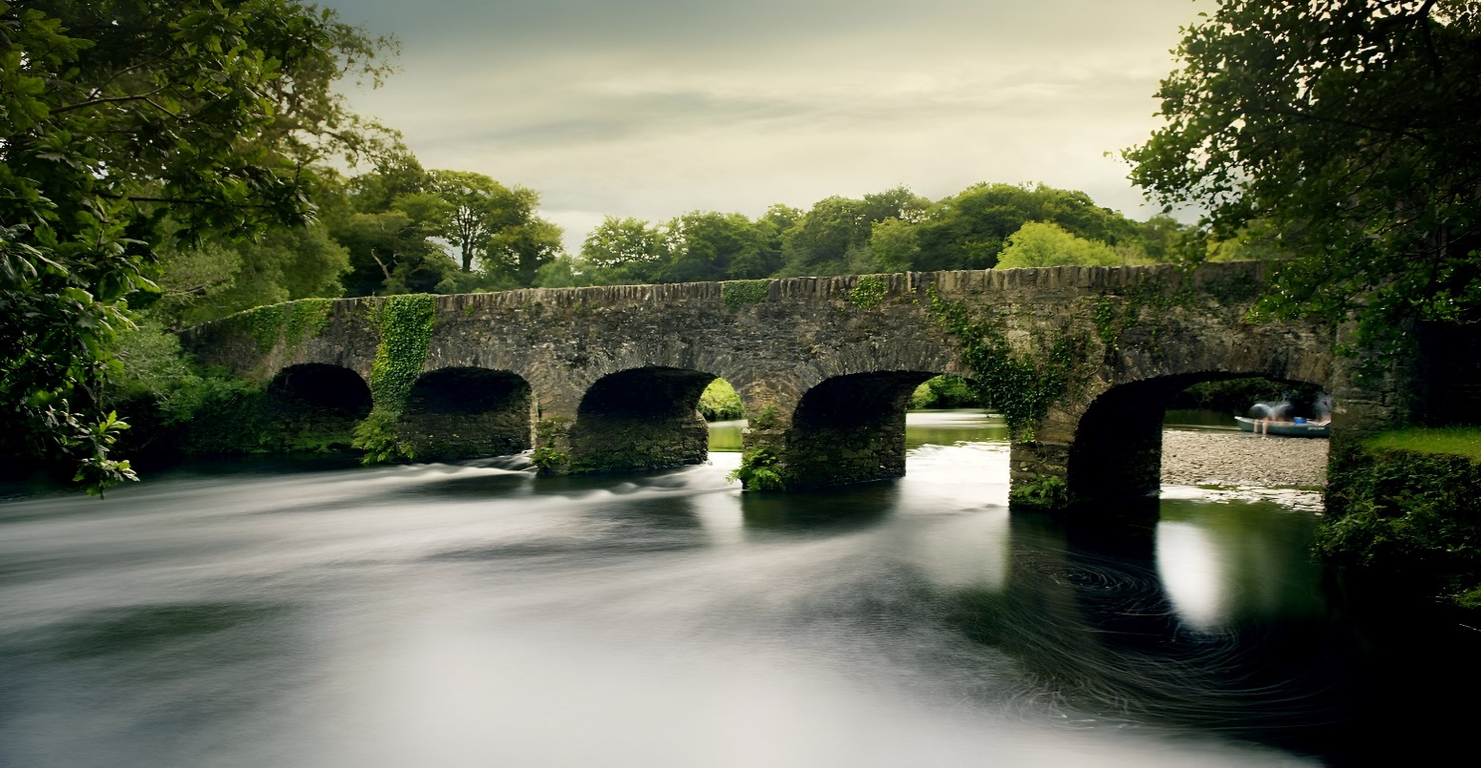

The Old Stirling Bridge, steeped in history and legend, stands as a timeless symbol of Scotland's rich heritage and turbulent past. Built in the late 15th century, this historic bridge spans the River Forth, connecting the city of Stirling with the surrounding countryside. With its rugged stone construction, towering piers, and iconic central arch, the bridge exudes an aura of medieval grandeur and architectural magnificence.

As one traverses the Old Stirling Bridge, they are transported back in time to an era of knights, kings, and battles fought for independence. The bridge's ancient stones whisper tales of valor and strife, echoing with the echoes of centuries-old conflicts that shaped the destiny of Scotland. From its vantage point, one can gaze upon the majestic Stirling Castle, perched atop its rocky promontory, and envision the historic events that unfolded within its walls.

Beyond its historical significance, the Old Stirling Bridge holds a special place in the hearts of Scots as a symbol of national pride and identity. It stands as a tangible reminder of Scotland's long struggle for independence and its enduring spirit of resilience and defiance in the face of adversity. Moreover, the bridge serves as a vital link between past and present, connecting modern-day Scots with their ancient heritage and cultural legacy.